**MODULE-1**

**ENTREPRENEURSHIP**

**Introduction and definition of Management:**

* Management is an activity concerned with guiding human and physical resources such that organizational goals can be achieved.

**Definitions of Management**

* According to Mary Parker Folley, “Management is the art of getting things done through People”.
* This definition shows the difference between manager and other personal of an organization.
* A manager contributes to the organizations goals by directing the effort of others - not performing the task by himself. A non managerial person contributes to the organizations goal by directly performing the task.

Two weakness of Mary Parker's definition are:

1. It uses the word art in defining management. Management is not merely application of knowledge. It involves accusation of knowledge, so it is a science.
2. Nothing mention about function of a manager

Definition of Management(Contd.)

* George R. Terry defines management, “as a process consisting of planning, organizing, actuating and controlling performed to determine and accomplish the objectives by the use of people and resources”.
* According to this definition management is a process that is a systematic way of doing things.
* This definition also throws light into the functions of management.

**Functions of Management or Management Processes:**

* PLANNING
* ORGANIZING
* STAFFING
* DIRECTING
* CO-ORDINATION
* CONTROLLING
* REPRESENTATION

**PLANNING:**

* Planning means looking ahead and chalking out future courses of action to be followed taking into consideration available and prospective human and physical resources.
* It is a systematic activity which determines when, how and who is going to perform a specific job.
* It is rightly said - Well plan is half done!. According to Koontz & O‘Donnell, - Planning is deciding in advance what to do, how to do and who is to do it. Planning bridges the gap between where we are, to where we want to go. It makes possible things to occur which would not otherwise occur.
* Planning requires administration to assess appropriate course of action to attain the company‘s goals and objectives.

**Steps in planning function**

1.Establishment of Objectives: (A) Setting of goals and objectives to be achieved. (B) Stated in a clear, precise and unambiguous language. (C) Stated in quantitative terms; Should be practical, acceptable, workable and achievable.

2. Establishment of Planning Premises: Planning premises may be internal or external. Internal includes capital investment policy, management labour relations, philosophy of management, etc. External includes socio- economic, political and economical changes. Internal premises are **controllable** whereas external are **non controllable**.

3. Choice of Alternative Course of Action: (A) A number of alternative course of actions have to be considered. (B) Evaluate each alternative in the light of resources available. (C) Chose the best alternative.

4. Securing Co-operation: After the plans have been determined, it is necessary rather advisable to take subordinates or those who have to implement these plans into confidence. This motivates them, valuable suggestions can come and employees will be more interested in the execution of these plans.

5. Follow up/Appraisal of Plans: After the selected plan is implemented, it is important to appraise its effectiveness and correct deviations or modify the plan as required.

**ORGANIZING:**

* Organizing is the function of management, which follows planning. It is a function in which the synchronization and combination of human, physical and financial resources take place.
* All the three resources are important to get results. Therefore, organizational function helps in achievement of results, which in fact is important for the functioning of a concern. Hence, a manager always has to organize in order to get results.

A manager performs organizing function with the help of the following steps:

1. Identification of activities - All the activities, which have to be performed in a concern, have to be identified, grouped and classified into units.
2. Departmentally organizing the activities - dividing the whole concern into independent units and departments is called depart-mentation.
3. Classifying the authority: Authorities bring smoothness in a concern‘s working environment.
4. Co-ordination between authority and responsibility: Each individual is made aware of his authority and knows whom they have to take orders from and to whom they are accountable and to whom they have to report.

**Management and Administration:**

* According to Spreigal, “Administration is that phase of business enterprise that concerns itself with the overall determination of institutional objectives and the policies necessary to be followed in achieving those objectives.
* Management on the other hand is an executive function which is primarily concerned with carrying of broad policies laid down by the administration”.
* 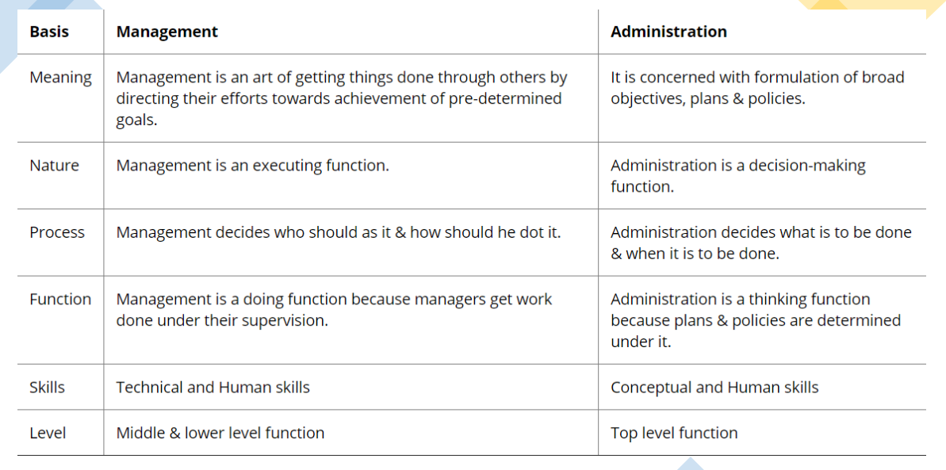Administration deals with establishing objectives and policies and is done by the top level whereas management is the execution of these policies by the middle and lower organizational level.

**Characteristics of Management:**

* Management is a continuous process
* involves continuous planning, organizing, directing and controlling
* Management is an art as well as science
* is an art in the sense of possessing managing skill by a person.
* is science because certain principles, laws are developed which are applicable in place where group activities are coordinated.
* Management aims at achieving predetermined objectives
* Management is a factor of production
* enterprise produce goods or services using resources like land, labour, capital, machines etc.
* These resources themselves cannot realize the organizations goals.
* The goals are achieved when these are effectively coordinated by the entrepreneur(Manager).
* Management is decision-making
* The success or failure of an organization depends upon the quality of decision.
* A manager must make a right decision at right time.
* Universal application
* principles and concepts of management are applicable to every type of industry.
* Dynamic
* Over a period of time new principles, concepts and techniques are developed and adopted by management.
* Management is changed accordingly to the social change
* Management is a profession
* it possesses the qualities of a profession.
* The knowledge is imported and transferred.
* The established principles of management are applied in practice.
* Management is a discipline
* implies that it is an accumulated body of knowledge that can be learnt.
* Management is a subject with principles and concepts.
* The purpose of studying management is to learn how to apply these principles and concepts at right circumstances, at the right time to produce desired result.

**Nature of Management:**

* Multidisciplinary
* It draws freely ideas and concepts from the disciplines like economics, sociology, psychology, statistics, operations research etc.
* Management integrates the ideas taken from various disciplines and presents newer concepts which can be put into practice.
* Relative not absolute principles
* These must be applied according to the need of the organization.
* Each organization is different from other. The principles of management should be applied in the light of prevailing conditions
* Management – science or art
* Earlier management was regarded as art but now it is both science and art.
* Universality of management
* Though universal yet management principles are not universally applicable but are to be modified according to the needs of the situation

**Management Approaches:**

* **Early Management Approaches**
* **Modern Management Approaches**
* **Early Management Approaches**
* Psychological Development
* Scientific Management
* Administrative Management
* Human Relation Movement
* Psychological Development (Before 17th Century)
* Olden days there was no experience of knowledge and business
* Depend upon their inborn abilities
* People were having universal belief that managers are born
* Scientific Management (18th – 19th Century)
* The efforts of scientists to demonstrate the application of science and scientific methods
* Effort of establishing standard practices
* Frederik Winslow Taylor has been considered as Father of Scientific Management
* Administrative Management
* Henri Fayol – Father of administrative management
* Theory focused on development of administrative principles applicable to middle and top managers.
* Fayol suggested 14 principles of Management

**Fayols’ 14 Principles of Management:**

* **Division of work**
* division of work is the course of tasks assigned to, and completed by, a group of workers in order to increase efficiency
* **Authority and responsibility**
* Authority means a formal, institutional or legal power in a particular job, function or position that empowers the holder of that job, function or position to successfully perform his task.
* Responsibility is the obligation of a subordinate to perform a duty, which has been assigned to him by his superior.
* **Discipline**
* According to Fayol, “Discipline means sincerity, obedience, respect of authority & observance of rules and regulations of the enterprise”.
* **Unity of command**
* Unity of command holds that an employee should only be answerable to one person
* **Unity of direction**
* Teams with the same objective should be working under the direction of one manager, using one plan.
* **Subordination of individual interest to general interest**
* Individuals should pursue team interests over personal ones – including managers.
* **Remuneration of personnel**
* Employee satisfaction depends on fair remuneration for everyone – financial and non-financial.
* **Centralization**
* Balancing centralized decision making (from the top) with letting employees make decisions.
* **Scalar chain**
* Scalar chain is a chain of all supervisors from the top management to the person working in the lowest rank
* any information should follow a pre-defined path, which is from the supervisor to the one in lowest position, to avoid any ambiguity.
* **Order:**
* a right person should be placed at the right job and a right thing should be placed at the right place.
* According to Fayol, every enterprise should have two different orders-Material Order for Physical Resources and Social Order for Human Resources.
* **Equity**
* Equity means combination of fairness, kindness & justice.
* The employees should be treated with kindness & equity if devotion is expected of them.
* It implies that managers should be fair and impartial while dealing with the subordinates.
* **Stability of tenure of personnel**
* principle stating that in order for an organization to run smoothly, personnel (especially managerial personnel) must not frequently enter and exit the organization.
* Initiative
* Initiative refers to the first step taken by the employees towards their self motivation.
* This principle states that employees **at all levels should be given freedom to some extent** so that they can come forward and use their skills to achieve expected goals.
* Union is Strength
* principle states that **an organization must make every effort to maintain group cohesion in the organization**.
* It notes that dividing your competition is a clever tactic, but dividing your own team is a serious error.
* Human Relations Approach
* The human rationalists focused as human aspect of industry.
* They emphasize that organization is a social system and the human factor is the most important element within it.
* Elton Mayo conducted experiments (known as Hawthorne experiments) and investigated informal groupings, informal relationships, patterns of communication, patterns of internal leadership etc.
* Elton Mayo is generally recognized as father of Human Relations School.

**Modern Management Approaches:**

* **Behavioural Approach**
* Concerned with applications of methods and findings for the purpose of understanding the organizational behaviour.
* improved and more matured version of human relations approach
* Motivation Theory, leadership, communication and employee motivation are some of the behavioral theories of management.
* **Quantitative Approach**
* also known as management approach started during Second World War during which each participant country of the war was trying to seek solutions to a number of new and complex military problems
* The focus of quantitative approach is on decision making, and to provide tools and techniques for making objectively rational decisions.
* **Systems Approach**
* A system is a set of interdependent parts which form a unit as a whole that performs some function
* An organization is also a system composed of four independent parts namely, task, structure, people and technology
* The central to the system approach is ‘holism’ which means that each part of the system bears relation of interdependence with other parts and hence no part of the system can be accurately analyzed and understood apart from the whole system
* **Contingency Approach**
* According to this approach, management principles and concepts have no general and universal application under all conditions.
* Methods and techniques which are highly effective in one situation may not give the same results in another situation.
* This approach suggests that the task of managers is to identify which technique in a situation best contribute to the attainment of goals
* Contingency views are applicable in designing organizational structure, in deciding degree of decentralization, in motivation and leadership approach, in **establishing** communication and control systems, in managing conflicts and in employee development and training

**Concept of Entrepreneur:**

* The word “Entrepreneur” is derived from the French verb ‘entreprendre’ which means ‘to undertake’.
* Entrepreneur is another name of Risk Taker. An entrepreneur is an individual who takes moderate risks and brings innovation.
* Entrepreneur is a person who organizes/ manages the risks in his/her enterprise. “Entrepreneur is an individual who takes risks and starts something new”
* French economist Richard Cantillon used the term entrepreneur for business. Since that time the word entrepreneur means one who takes the risk of initiating a new organization or introducing a new thought, product or service to society
* The views are broadly classified into three groups, namely risk bearer, organizer and innovator
* Entrepreneur as risk bearer:
* Richard Cantilon defined entrepreneur as an agent who buys factors as production at certain prices in order to combine them into a product with a view to selling it at uncertain prices in future.
* Entrepreneur as an organizer:
* According to J Baptist Say “an entrepreneur is one who combines the land of one, the labor of another and capital of yet another, and thus produces a product. By selling the product in the market, he pays interest on capital, rent on land and wages to laborers and what remains is his/her profit”.
* Entrepreneur as an innovator:
* Joseph A SchumPeter assigned a crucial role of ‘innovation’ to the entrepreneur. He considered economic development as a dynamic change brought by entrepreneur by instituting new combinations of factors of production, i.e. innovations.
* Hence, an entrepreneur is the person who undertakes risk, combines various factors of production, exploits the supposed opportunities, and creates wealth and employment
* **Entrepreneurship** is the process of finding opportunities in the market place, planning for the resources required to convert these opportunities into success and to achieve long term gains.
* It involves creating capital by exploiting resources in new ways to initiate and operate an enterprise.

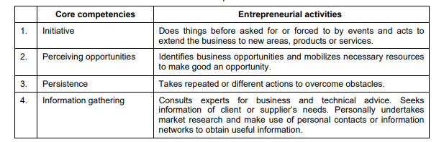**CHARACTERISTICS OF ENTREPRENEUR:**

**Distinction between Entrepreneur and Manager:**

**Types of Entrepreneur:**

* **According to type of business**

1. **Business entrepreneur**

* Are individuals who conceive an idea for a new product or service
* deals with product development and sales
* Trading Entrepreneur
* Undertakes trading activities and not concerned with manufacturing work

1. **Industrial Entrepreneur**

* Is generally a manufacturer who identifies potential needs of customers and tailors a product or service to meet marketing needs

1. **Corporate Entrepreneur**

* Demonstrates the innovative skill in organizing and managing corporate undertaking

1. **Agricultural Entrepreneur**

* Undertake agricultural activities such as raising and marketing of crops fertilizers and other inputs of agriculture.

1. **Retail Entrepreneur**

* Retail entrepreneurs organise business processes and concepts in his/her personally owned business
* **According to use of Technology**

1. **Technical Entrepreneur**

* Also called draftsman who develops improved quality goods
* Oriented towards manufacturing rather than marketing

1. **Non Technical Entrepreneur**

* Not concerned with technical aspects of the product
* Concerned with alternative marketing and distribution strategies

1. **Professional Entrepreneur**

* Is a person whose interest is to establish business and does not deal with management and organization
* **According to motivation**

1. **Pure Entrepreneur**

* Is a person who gets motivated by psychological and not by economic rewards
* Works for his own satisfaction and for his own status

1. **Induced Entrepreneur**

* Is one who is induced to take up tasks due to policy measures that provide assistance incentives and concessions

1. **Motivated Entrepreneur**

* They are motivated by the desire of self fulfillment
* They come into existence because of the possibility of making and marketing new products

1. **Spontaneous Entrepreneur**

* They start their business by natural talents inherent in them
* Possess traits like initiative boldness and self confidence
* **According to stages of development**

1. **First generation Entrepreneur**

* One who starts an industrial unit by his own innovative ideas and skills

1. **Modern Entrepreneur**

* Is one who undertakes those projects that are well needed and suited for changing demands

1. **Classical Entrepreneur**

* One who is concerned with customers and marketing needs with developing new venture
* **According to Scale of Operation**

1. **Small Scale Entrepreneur**

* These entrepreneurs do not possess the necessary talents and resources to initiate large-scale production and to introduce revolutionary technological changes

1. **Large Scale Entrepreneur**

* possess the necessary financial and other resources to initiate and introduce new technological changes.
* They possess talent and research and development facilities.

**Types of ownership and Organization structures:**

* **Types of ownership:**
  + - Sole proprietor
    - Partnership
    - Limited Liability company
    - Corporation
    - Cooperative
* Each business structure has distinct advantages and disadvantages compared to the other forms of ownership.

**Sole proprietorship:**

* The most common and the simplest type of business ownership is the sole proprietorship.
* In a sole proprietorship, a single individual engages in a business activity without necessity off normal organization.
* A sole proprietorship is not considered to be an entity separate from the owner, may not be owned by more than one person, and provides no protection against liability to the owner.

Ex: Bakers and Chefs, Fitness Instructor, Direct Sellers

**Advantages:**

* Easy set up
* Simple Licensing and paper work
* Total control
* Profit to owner
* Profits taxed once
* Few Government Regulations

**Disadvantages:**

* Limited Capital
* Unlimited Liability
* Limited Human Resource
* Limited Life

**General partnership:**

* A general partnership is created when two or more persons associate to carry on a business for profit.
* A partnership generally operates in accordance with a partnership agreement, but there is no requirement that the agreement be in writing and no state-filing requirement.
* Partnership are usually terminable at will or at the death of any of the partners, and partnership interests cannot be sold or transferred without the consent of the other partners.
* Partnerships are considered in most states to be an entity separate from the partners, so that a partnership can own property and sue and be sued in its own name.
* Spotify & Uber , Louis Vuitton & BMW

**Advantages:**

* Easy set-up
* More Skills and knowledge
* Available capital
* Total control by partners
* Profits taxed once

**Disadvantages:**

* Unlimited Liability
* Possible disagreement among partners
* Shared Profits
* Limited life

**Limited Liability Company:**

* A limited liability company is created by filing a documents with the state.
* The limited liability company (LLC) is not a partnership or a corporation but rather is a distinct type of entity that has the powers of both a corporation and a partnership.
* Depending on how the LLC is structured, it may be likened to a general partnership with limited liability, or to a limited partnership where all the owners are free to participate in management and all have limited liability
* The liability of the owners is limited to their investments
* Profits are taxed only once
* Smaller Businesses

**Corporation:**

* Formation of a corporation requires filing documents with the state government.
* A corporation is a legal person, separate from its owners, with the characteristics of limited liability, centralization of management, perpetual duration, and ease of transferability of ownership interests.
* The owners of a corporation are called “shareholders.”
* The persons who manage the business and affairs of a corporation are called “directors.”
* However, state corporate law does provide for shareholders to enter into shareholders’ agreements to eliminate the directors and provide for shareholder management.
* Choosing the best management structure for your corporation is a decision you make with the advice of an attorney.

Amazon, Google, Apple

**Advantages:**

* Ability to raise capital
* Limited Liability
* Continued life
* Separation of ownership and management
* Stocks

**Disadvantages:**

* Complex and expensive setup
* Slow decision making process
* Taxes- double taxation – once on profits and once on dividends

**Cooperative:**

* A cooperative is a private business owned and operated by the same people that use its products and or services.
* The purpose of a cooperative is to fulfill the needs of the people running it.
* The profits are distributed among the people working within the cooperative, also known as user-owners.

**Advantages:**

* Employees are Engaged
* Only taxed on their income

**Disadvantages:**

* Hard to receive Outside funding

**Organization structures:**

* An organizational structure is a system that outlines how certain activities are directed in order to achieve the goals of an organization
* These activities can include rules, roles, and responsibilities
* The organizational structure also determines how information flows between levels within the company.

**Organizational Chart:**

* An organizational chart is a diagram that visually conveys a company's internal structure by detailing the roles, responsibilities, and relationships between individuals within an entity
* Organizational charts are alternatively referred to as "org charts" or "organization charts.“
* Organizational chart is the visual representation of this vertical structure
* The structure should clearly determine the reporting relationships and the flow of authority as this will support good communication –resulting in efficient and effective work process flow.

**Types of Organizational Structures:**

* Companies generally adopt one of four organizational structures. These include:
  + Line structure
  + Line and staff structure
  + Matrix structure
  + Team structure
* Each of these different types of organizational structures can be shown in an organizational chart

1. 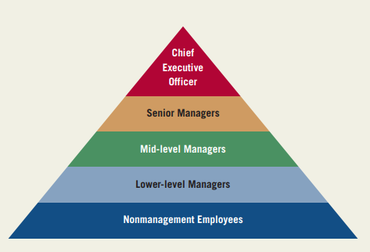**Line structure:**

* In a line organization, authority originates at the top and moves downward in a line
* All managers perform , functions that contribute directly to company profits.
* Examples of line functions include production managers, sales representatives, and marketing managers.
* Line managers collect and analyze all of the information they need to carry out their responsibilities.
* Production managers, for example, hire and fire all of the assembly-line workers in their departments.

They also order all of the supplies their department needs.

1. 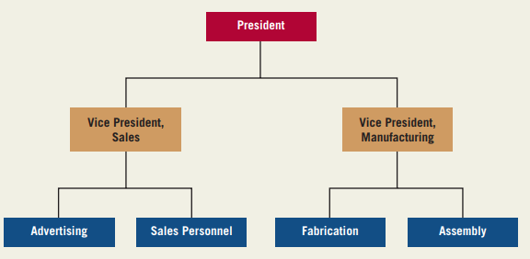**Line and Staff Structure:**

* In mid-sized and large companies, other employees are hired to help line managers do their jobs.
* These employees perform staff functions
* Staff functions advise and support line functions.
* Staff departments include the legal department, the human resources department, and the public relations department.
* These departments help the line departments do their jobs
* They contribute only indirectly to corporate profits.
* Staff people are generally specialists in one field, and their authority is normally limited to making recommendations to line managers.

1. 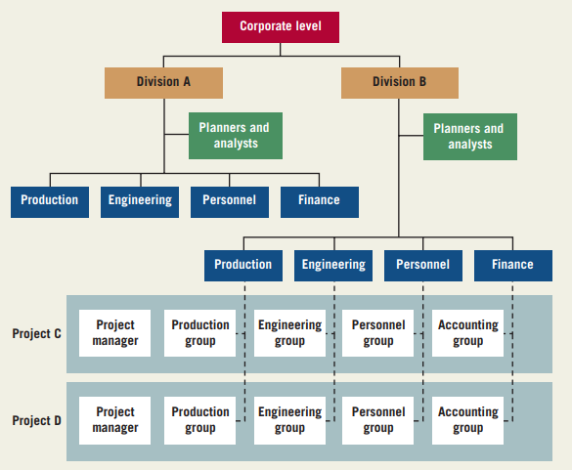**Matrix Structure:**

* A matrix structure allows employees from different departments to come together temporarily to work on special project teams.
* The purpose of this kind of structure is to allow companies the flexibility to respond quickly to a customer need by creating a team of people who devote all of their time to a project.
* Once the team completes the project, the team members return to their departments or join a new project team.
* Companies that undertake very large projects often use the matrix structure.
* Ex: Boeing, large tech firms

1. **Team Structure:**

* A team structure brings together people with different skills in order to meet a particular objective.
* More and more companies are using the team structure.
* They believe this structure will allow them to meet customer needs more effectively than the traditional structure
* Senior Managers need not approve decision of lower level managers
* Teams have the authority to take their own decision
* Example -IBM

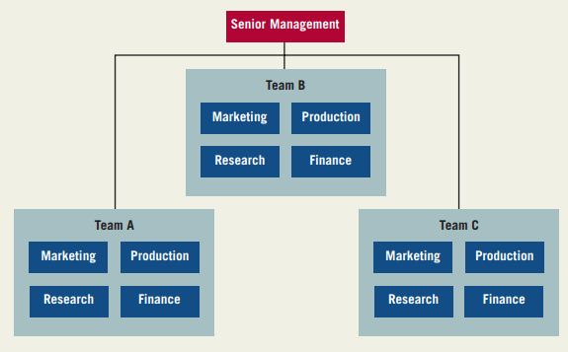

**Examples:**

ORGANIZING A COMPANY BY PRODUCT

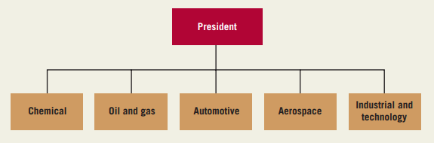

**Role of Entrepreneurs in Economic Development:**

1. Entrepreneurship promotes capital formation by mobilizing the idle saving of the public.
2. It provides immediate large-scale employment. Thus it helps to reduce unemployment in the country.
3. It provides balanced regional development.
4. It helps reduce the concentration of economic power
5. It stimulates the equitable redistribution of wealth, income and even political power in the interest of the country.
6. It encourages effective resources mobilization of capital and skill which might otherwise remain unutilized and idle.
7. It induces backward and forward linkages which stimulated the process of economic development in the country.
8. It promotes country’s export trade i.e. an important ingredient for economic development

**Entrepreneurship development and Govt.support in India:**

* Entrepreneurship development (ED) refers to “the process of enhancing entrepreneurial skills and knowledge through structured training and institution-building programmes”.
* Entrepreneurship development focuses on the individual who wishes to start or expand a business.
* Small and medium enterprise (SME) development, on the other hand, it also focuses on developing the enterprise, whether or not it employs or is led by individuals who can be considered entrepreneurial
* **SAMRIDH Scheme**
* Startup Accelerators of MeitY for PRoduct Innovation, Development, and growth launched on Aug 25 2021
* SAMRIDH initiative is designed to provide funding support to startups along with helping them bring skill sets together which will help them grow successful.
* Startup India Seed Fund
* On 16 January 2021, Prime Minister Narendra Modi announced the launch of the 'Startup India Seed Fund' — worth INR 1,000 crores — to help startups and support ideas from aspiring entrepreneurs.
* **Startup India Initiative**
* launched in the year 2016 on 16th January.
* The idea is to increase wealth and employability by giving wings to entrepreneurial spirits.
* The government gives tax benefits to startups under this scheme and around 50,000 startups have been recognized via this scheme in a period of a little more than five years, as of June 3, 2021.
* **ASPIRE**
* A Scheme for Promotion of Innovation, Rural Industries and Entrepreneurship (ASPIRE) is a Government of India initiative and promoted by the Ministry of Micro, Small and Medium Enterprises (MSME).
* scheme was launched in 2015 to offer proper knowledge to the entrepreneurs to start with their business and emerge as employers.
* Since 56% of the Indian population lives in rural areas, the government has promoted entrepreneurship and innovation in the rural sector with this scheme. The ASPIRE scheme aims at increasing employment, reducing poverty, and encouraging innovation in rural India.
* **MUDRA Bank**
* Micro Units Development Refinance Agency (MUDRA) banks has been created to enhance credit facility and boost the growth of small business in rural areas.
* The government has introduced this scheme to support small businesses in India.
* The MUDRA banks provides startup loans of up to INR 10 lakhs to small enterprises, business which are non-corporate, and non-farm small/micro enterprises.
* MUDRA comes under Pradhan Mantri Mudra Yojana (PMMY) which was launched on 8 April 2015. The loans have been categorized as Tarun, Kishore, and Shishu.
* **Ministry of Skill Development and Entrepreneurship**
* The task of promoting entrepreneurship was earlier given to different departments and government agencies.
* In 2014, the Government decided to dedicate an entire ministry to build this sector as skill development required greater push from the government's side.
* **ATAL Innovation Mission**
* Announced in the budget session of 2015, the Atal Innovation Mission (AIM); with the name coming from Atal Bihari Vajpayee, the Former Prime Minister of India.
* Atal Innovation Mission was established to create a promotional platform involving academicians and draw upon national and international experiences to foster a culture of innovation, research, and development.
* The government allocated AIM around INR 150 crores in the year 2015.
* **Dairy Processing and Infrastructure Development Fund (DIDF)**
* National Bank for Agriculture and Rural Development (NABARD) is an apex development bank in India.
* The Government of India announced the creation of Dairy Processing and Infrastructure Development Fund under NABARD in the Union Budget of 2017-18 for the sustained benefit of farmers.
* The total corpus for this fund is INR 8000 crores over a period of 3 years (i.e. 2017-18 to 2019-20)
* Milk Unions, multi-state milk cooperatives, state dairy federations, milk producing companies, and NDDB subsidiaries meeting the eligibility criteria under the project can borrow loan from NABARD.
* **Support for International Patent Protection in Electronics & Information Technology (SIP-EIT)**
* The Department of Electronics and Information Technology (DeiTY) has launched a scheme entitled “Support for International Patent Protection in E&IT (SIP-EIT)”. This scheme provides financial support to MSMEs and Technology Startups for international patent filing
* Financial support is provided for international filing in Information Communication Technologies and Electronics sector.
* The Reimbursement limit has been set at a maximum of INR 15 lakhs per invention or 50% of the total charges incurred in filing and processing of a patent application, whichever is lesser.
* The SEP-EIT scheme can be applied at any stage of international patent filing by the applicant.
* **Multiplier Grants Scheme (MGS)**
* Department of Electronics and Information Technology (DeitY) started the Multiplier Grants Scheme (MGS).
* This scheme aims to encourage collaborative Research & Development (R&D) between industry and academics/institutions for the development of products and packages.
* Under the scheme, if the industry supports the R&D of products that can be commercialized at the institutional level, the government shall provide financial support which will be up to twice the amount provided by industry. MGS promotes and expedites the development of aboriginal products and packages.
* **Credit Guarantee Fund Trust for Micro and Small Enterprises (CGTMSE)**
* The Credit Guarantee Fund Trust for Micro and Small Enterprises (CGTMSE ) was set up by the government of India and had been put to effect from 1st January 2000 onwards to provide business loans to micro-level businesses, small-scale industries, and startups with zero collateral.
* It allows businesses to avail loans at highly subsidized interest rates without requiring security.
* The Government along with SIDBI (Small Industries Development Bank of India) provides a maximum amount of up to INR 100 lakhs under this scheme for boosting new enterprises as well as rehabilitating the existing ones.
* **Software Technology Park (STP)**
* The Software Technology Park (STP) scheme is a totally export-oriented scheme for the development and export of computer software. This includes the export of professional services using communication links or media.
* The scheme integrates the government concept of "100% Export Oriented Units" (EOU), "Export Processing Zones" (EPZ), and the concept of Science Parks or Technology Parks as operating elsewhere in the world.
* **Loan For Rooftop Solar Pv Power Projects**
* To build reliance on non-conventional sources of power, the government of India has decided to set up 40,000 MWp of Grid-Interactive Rooftop Solar PV Plants in the next five years.
* These rooftop solar PV plants will be set up in residential, commercial, industrial, and institutional sectors in the country and shall range from 1 kWp to 500 kWp in terms of capacity.
* **NewGen Innovation and Entrepreneurship Development Centre (NewGen IEDC)**
* NewGen IEDC is an initiative launched by the National Science and Technology Entrepreneurship Development Board under the Department of Science and Technology, Government of India.
* The initiative aims to inculcate the spirit of innovation and entrepreneurship among the Indian youth. It also endeavors to support and encourage entrepreneurship through guidance, mentorship, and support.
* **Modified Special Incentive Package Scheme (M-SIPS)**
* Government of India has approved a special incentive package to promote large-scale manufacturing in the Electronic System Design and Manufacturing (ESDM) sector. The scheme is called the Modified Special Incentive Package Scheme (M-SIPS).
* Under M-SIPS, the Indian government will provide a subsidy of 20% on capital investments in special economic zones (SEZs) and 25% on capital investments in non-SEZs for individual companies.